  
Digital Health Modernization/

Medications (MHV to VA.gov)

(Q1 2025) |

Version 3

Revision History

Adding grouping of medications on details page.

Revision History 1

1. Product Overview 1

2. User Access 2

3. Navigation 3

4. Functionality 6

5. Major Issues and Error Messages 11

6. Table of Figures 12

# Product Overview

Medications on VA.gov will provide Veterans with a comprehensive online pharmacy experience utilizing familiar legacy features found on My HealtheVet today with various enhancements to the tool. The new application on VA.gov will provide a personalized experience influenced by user-centered-design methodologies to create a seamless pharmacy experience, empower Veterans, and build trust with the VA.

1.1 Assumptions and Standards

Medications on VA.gov replaces My HealtheVet’s table design with a card layout. Each prescription, either medication or supply, is given a card with specific information about that prescription. Each card has the same general layout but can present different statuses and action elements depending on the condition of the prescription.

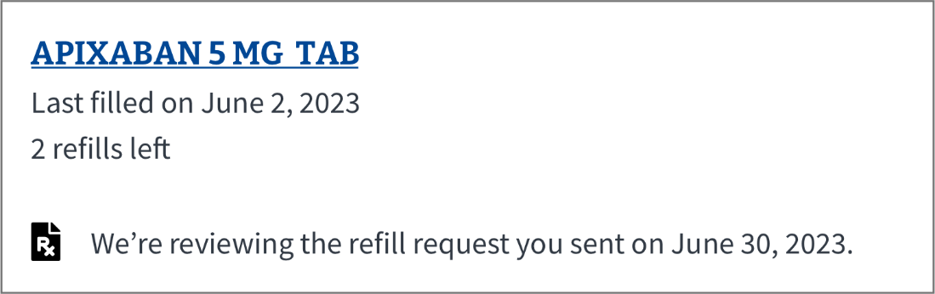

*Figure 1a: Desktop card showing Refill submitted status*

# User Access

In the next release (Phase 1), functionality will be linked to VA.gov. Users will see an access link on MHV national portal to allow anyone who would like to try the new tool out. The MHV on VA.gov landing page will also directly link to the new VA.gov experiences.

Users who have authenticated on MHV national portal should not have to reauthenticate when directed to VA.gov UNLESS they have used option 2, MHV login. All users can still access their legacy/existing MHV Pharmacy experience by following the links on VA.gov.

2.1 Logging into VA.gov to access the new Medications

MHV national portal users can access by following the link in the Try Me banner on the Medications home page in MHV classic or by logging into VA.gov and going to the MHV on VA.gov landing page. Users who have authenticated on MHV national portal should not have to reauthenticate when directed to VA.gov UNLESS they have used option 2, MHV login..

2.2 Accessing the new Medications on VA.gov Landing Page

After logging in, approved users will land on the Medications landing page.

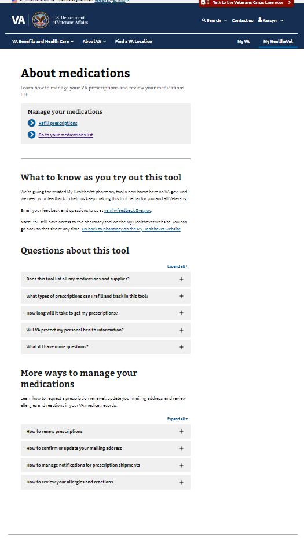

*Figure 2a: Desktop version of the Landing Page*

We are now embedding the experience into the existing VA.gov.

Access to the Medications tools is via link as seen below in image 2a. There are now two options: Navigate to the users medication list, and going to the refill page that only shows medications that need refilled or renewed.

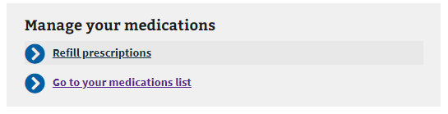

*Figure 2b: Link to Medications tool. After clicking the, “Go to your medications list” link users will be taken to the Medications List View page. After clicking the, “Refill prescriptions” link users will be taken to the Refill prescription page.*

2.3 Accessing the new Medications on VA.gov using secondary navigation

After logging in, users can click over to the MyHealtheVet section of va.gov to see a second way of accessing the medications tool. This option allows them to go straight to their medication list as well as the refill page just like the landing page, giving them quick access to those features.

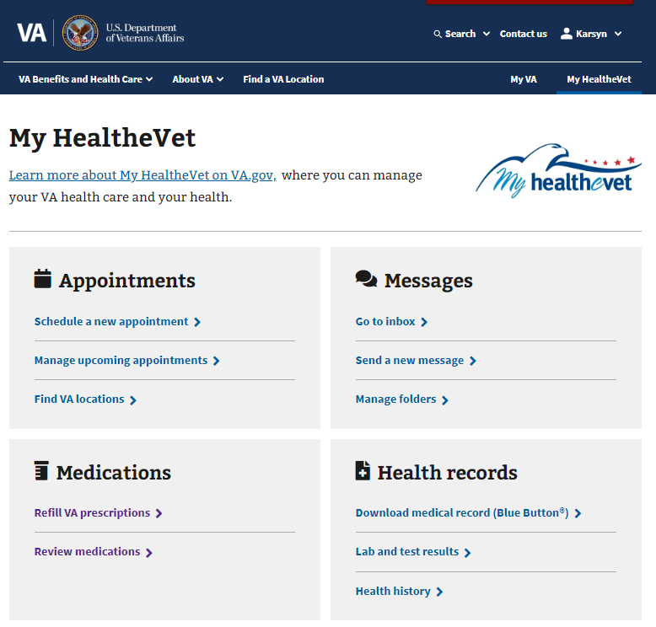

*Figure 2c: Secondary navigation option to get to the medications tool on VA.gov.*

# Navigation

Users can navigate to the tool using MHV Landing page as well as the secondary navigation. Once in the Medications tool, Veterans will be able to navigate to the three pages within the Medications application, the List View, Details page, and Refill page, through links and breadcrumbs.

3.1 List View navigation

Most navigation in the List View is conducted through the list of prescription cards. Depending on the status of the prescription, different navigation opportunities will be presented. The following navigation capabilities can be found within the cards:

* The Details page is accessed via link embedded in the name of the medication on the prescription card in the List View. Every card has an associated Details page
* Link back to the Landing page describing how to renew a prescription as shown in Figure 3b (when applicable)
* Link to the Secure Messaging tool on VA.gov (when applicable)

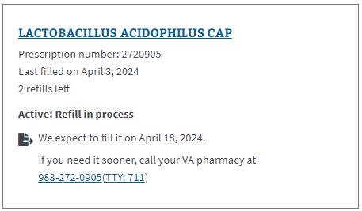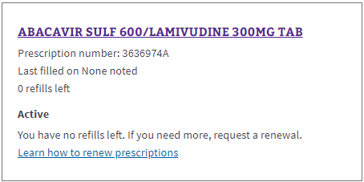

*Figure 3a: Active, Refill in process example Figure 3b: Active, no refills remaining example.*

3.2 Details Page navigation

The Details page contains the following navigational capabilities -

* External tracking link to delivery service website (when applicable)
* Breadcrumbs back to the previous page the user was on (list page)
* As found on the cards in the List View, links to the Landing page describing how to renew a prescription (when applicable)
* Link to the Secure Messaging tool on VA.gov (when applicable)

Tracking and shipment information can only be found on the Details page via alert as shown. External links to the delivery service website are offered.

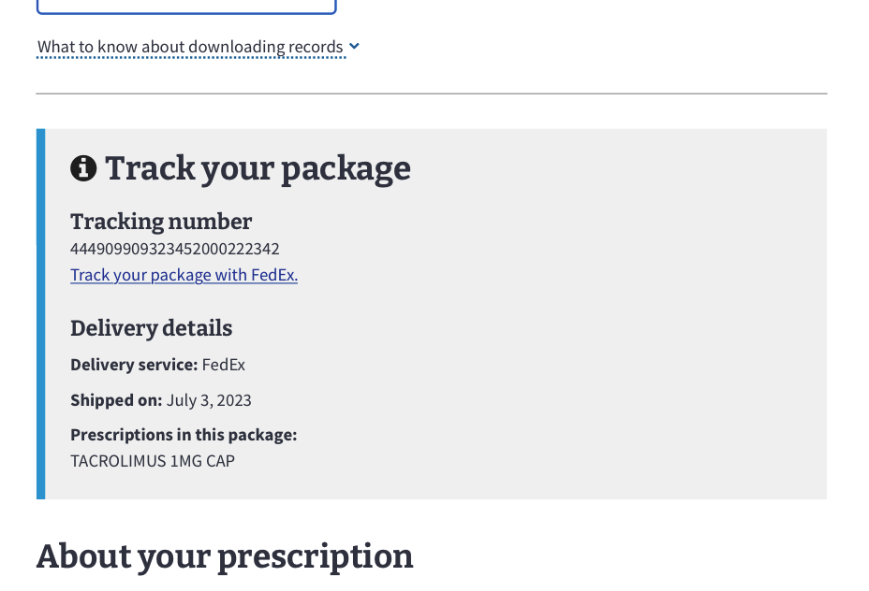

*Figure 3c: A tracking alert for Tacrolimus 1 MG CAP in desktop format.*

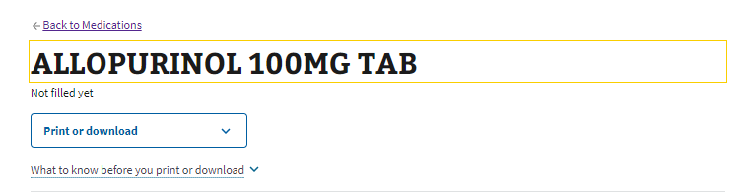

*Figure 3d: Breadcrumbs on the Details page on the desktop version*

# Functionality

The main purpose of the Medications tool is to give Veterans a streamlined, digital tool to refill their medications or supplies and the design reflects this priority in the List View page. Other capabilities are listed below.

4.1 Landing page



*Figure 4a: Desktop example of the Landing page for Medications on VA.gov*

* Access to the List View page via link
* Access to the Refill page via link
* Users have the following capabilities from the Medications Landing Page -
  + Open Medication List View – accessed via ‘Go to your medications list’ link
  + Open Refill page – accessed via ‘Refill prescriptions’ link
  + Provide feedback through the feedback button on the page
  + Return to the Pharmacy tool on My HealtheVet
  + A list of answers of frequently asked questions
  + Examples and guidance for external flows, like renewing prescriptions, updating/confirming your mailing address and reviewing allergies/adverse reactions

4.2 List View

The List View functions as a dynamic record of past and current VA and Non-VA prescriptions. It is where Veterans can navigate to the refill page, access the Details page for a specific prescription (see section 4.3) and view their comprehensive prescription history. By default, the prescription cards are sorted by ‘Alphabetically by status’ first and by a secondary sort of alphabetically by name. The sorting can be adjusted.

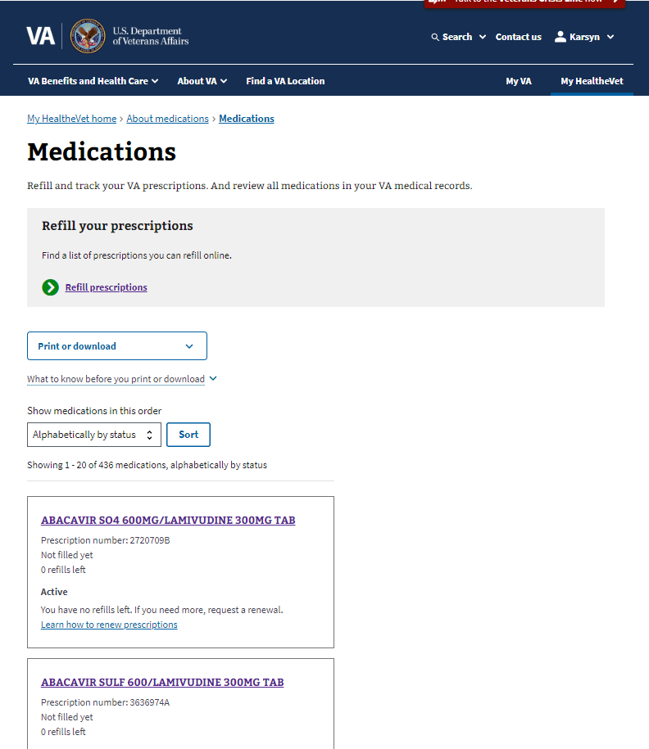

*Figure 4b: A desktop version of the List View page*

We have recently changed this page from including the ability to refill directly on this page to now separating that action to a different page. This allows for a more action page when it comes specifically to refills, the biggest action done in the medications tool. Once a prescription is refilled on that page, users are notified to go back to the medication list page to check the status of that refill. After a refill or fill is submitted, the card is updated throughout the refill process until the medication or supply has been shipped.

* Each card is updated throughout the refill process -
  + Refill available
  + Refill submitted
    - If a Veteran needs the medication sooner than the expected fill date, a pharmacy phone number will be provided for them to call.
  + Refill in process (no action available)
  + Refill shipped
    - Tracking information can be found on the Details page – see below

There will be many prescriptions that are ineligible for a refill due to various statuses. Previously, those statuses have confused Veterans. We have continued to show those statuses and placed ‘next step’ options and some clarifying text to help users understand why they may not be able to refill their prescription.

* Prescriptions with statuses that may prevent refills display the following -
  + 0 refills left - ‘To get more, renew this prescription’ with a like to ‘Learn how to renew prescriptions’ found on the Landing page
  + Discontinued – You can’t refill this prescription. If you have questions, send a message to your care team.’
  + Expired - ‘This prescription is too old to refill. If you need more, request a renewal.’
  + Unknown - ‘We can’t access information about your prescription right now. Call your pharmacy at XXX-XXX-XXXX.’

We have added a filter functionality that allows the user to filter down the medication list to specific options.

* All Medications -
* Active -
* Recently Requested -
* Renewal needed before refill
* Non-active -

Other functionality includes downloading and printing the list of prescriptions found in the List View. The user’s recorded allergies and adverse reactions are also found in the same printable file.

4.3 Details page

Each prescription has a Details page which provides an in-depth look at the history of the prescription as well as important information like the reason for use, the prescription expiration date, the prescription number, the status and its definition, and more.

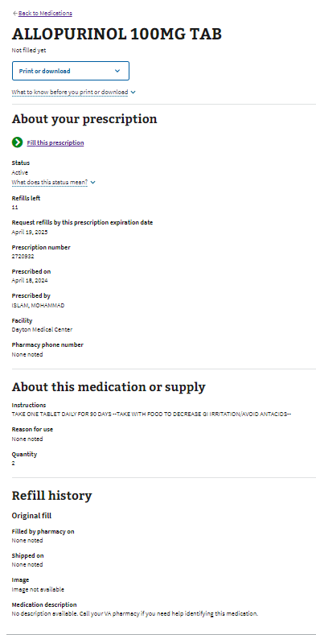

*Figure 4c: Desktop version of the Details page for Allopurinol 100MG TAB*

Each Details page is separated into 4 distinct sections with accompanying details -

* About your prescription
  + Status, with dropdown definition
  + Refills left
  + Request refills by this prescription expiration date
  + Prescription number
  + Prescribed on
  + Prescribed by
  + Facility
  + Pharmacy phone number
* About this medication or supply
  + Instructions
  + Reason for use
  + Quantity
* Refill history (Split out by each refill)
  + Filled by pharmacy on
  + Shipped on
  + Image
    - The drug image example provides a visual snapshot in the history of the medication. Many Veterans report their medications change color or shape, so having a recorded history of the medication is important in case the Veteran forgets or has any questions about what their medication looks like.
    - 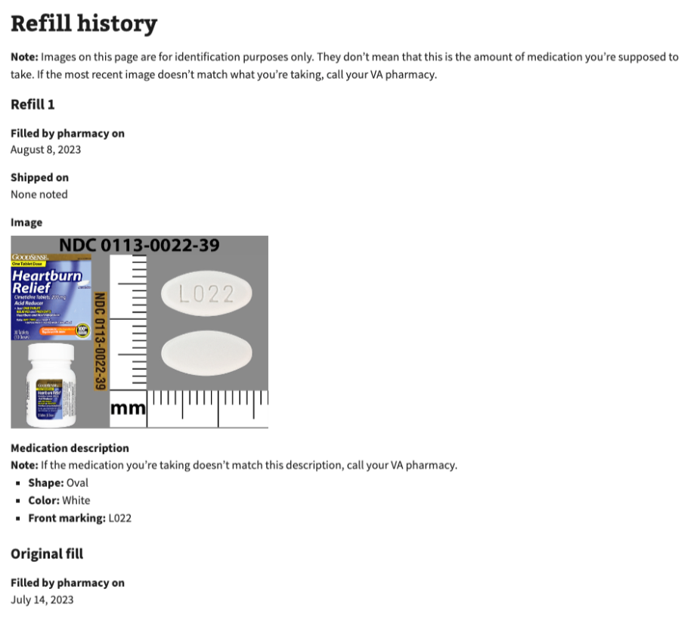
    - *Figure 4d: example of medication image opened*
  + Medication description
* Previous Prescriptions (Split out by each prescription)
  + This allows for the user to see their full history with this medication. This also reduces the amount of cards on the list page by grouping all the medications with the same prescription number together into one card.
  + Fields include:
    - Last filled on
    - Quantity
    - Prescribed On
    - Prescribed By
  + 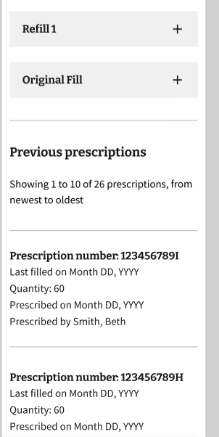

4.4 Refill page

The Refill page has two different sections. The first section is for the medications that are ready to refill. This is displayed as a list of medications and checkboxes that the user can check individually or all at once. Below this section is a list of medications the user will need to renew to refill them. This will help the user understand that if it is not in the ‘ready to refill’ list but is expected to be, it may be just because it ran out of refills and needs renewed.

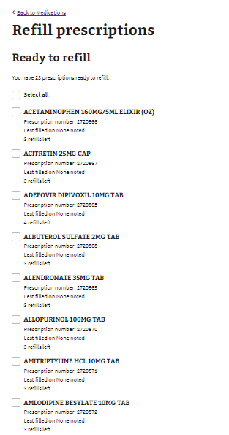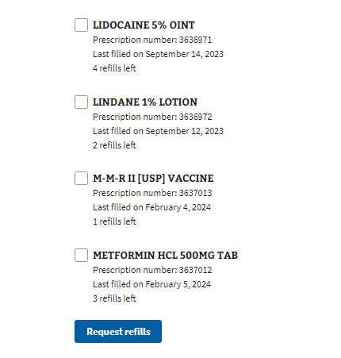

*Figure 4e: Refill page, refill section*

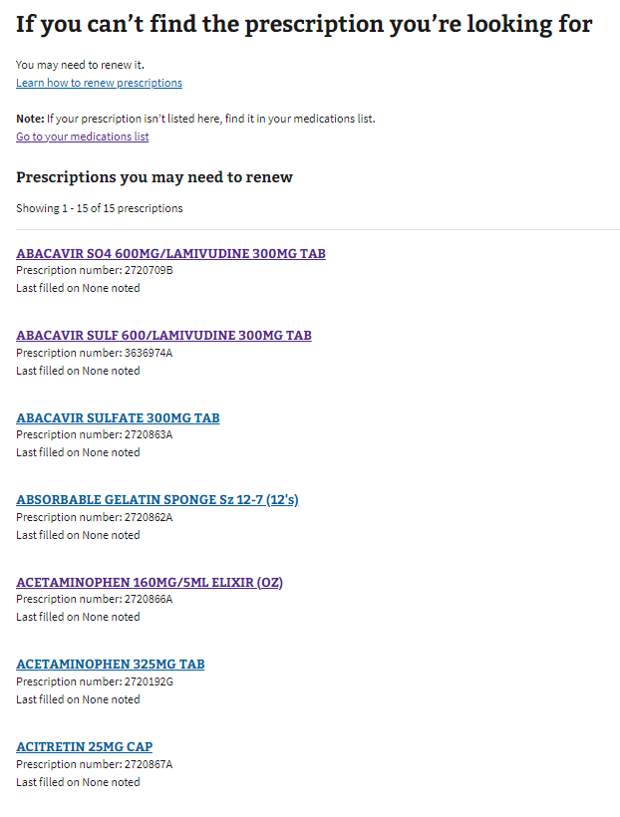

*Figure 4f: Refill page, renew section*

4.5 Download/Print

Users will have the option to download and/or print their comprehensive medication list on the List View page, or the details for individual medications on each Details page. All medications will be available to be printed, downloaded as PDF, and downloaded as a TXT. There are different options on the List page vs. the Details page as well. For the List page we offer printing only the page that the user is on as well as all medications, downloading a PDF of the list, and downloading a text file of the list. For the Details page we offer, printing the page, downloading a PDF of the page, and downloading a txt file of the page.

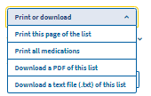

*Figure 4g: Print or download button on the List View page*

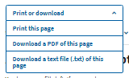

*Figure 4h: Print or download button on the List View page*

# 

# Major Issues and Error Messages

There are no major issues at this time.

Error messages are displayed similarly to refill status updates in the cards and on the Details page.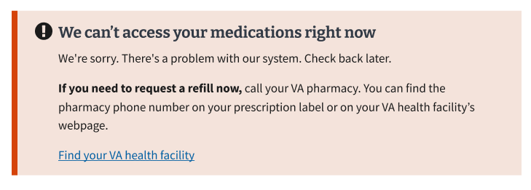

*Figure 5a: Example of a backend error when trying to fetch medication list*

1. Table of Figures

No Table of Figures information is available at this time.